19961

Manuscript leaf with two scenes: a couple discussing legalities with lawyers, and two lovers in a bed from a Decretum Gratiani
Southern France, probably Toulouse
c. 1320

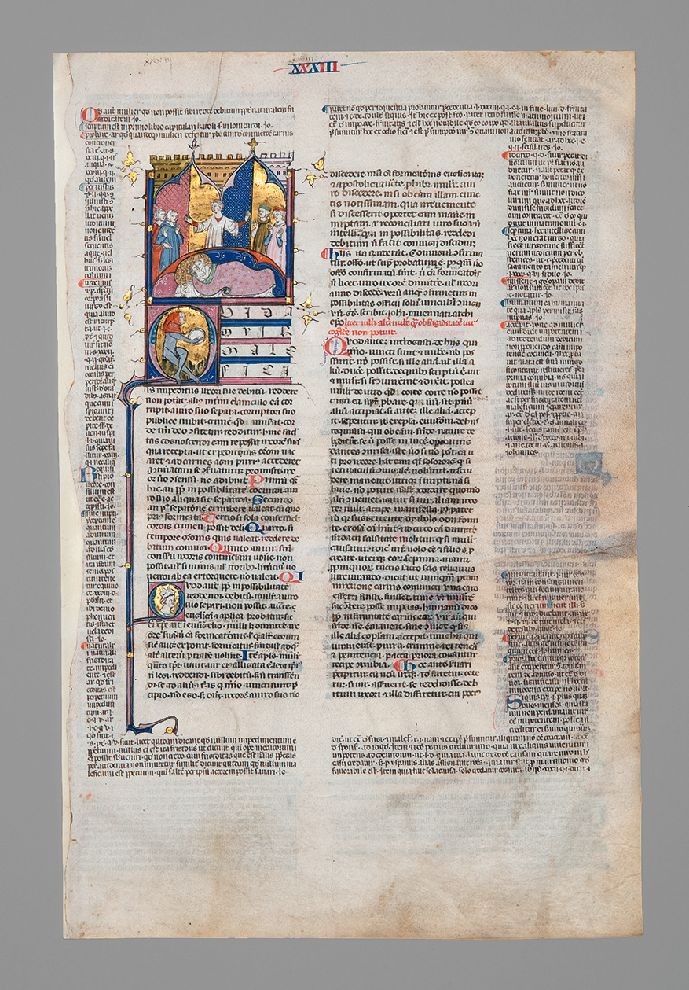

425 x 290 mm; illuminated manuscript with ink, tempera and gilding on parchment.

Provenance
Private collection, Germany;
McCarthy collection, London, since 2006

Published
Peter Kidd, The McCarthy Collection: French Miniatures (London, 2021), pp. 235 – 243.
This grand manuscript leaf with its illuminated images of a couple discussing legalities and two lovers embracing intimately in bed comes from a Decretum Gratiani, a legal textbook written in the first half of the 12th-century by a jurist known as Gratian. The textbook remained an essential source of canon law right up until the Catholic legal reforms of the early 20th century and this leaf recounts a complicated case (Causa XXXIII), in which a wife seeks divorce. Her husband became impotent, leading the wife to take a lover, whom she married. When the husband regained potency, he claimed the wife back, only to take the vow of celibacy without the wife’s permission. Gratian outlines the various legal dilemmas of this case, making suggestions how it should be handled and citing various theological authorities to back up his claims.
The lavishly illuminated miniature in the upper left part of the leaf depicts a crenelated building with two pointed arches within. Inside the architectural framework is a standing cleric, his arms gesticulating, acting as a judge between the husband and wife, who stand on one side, and two lawyers, who stand on the other. While the husband raises his hands in embarrassment, the wife smiles and points to an arched space in the lower part of this scene, which illustrates two lovers in a bed. Below this scene is a historiated initial with a blue hybrid creature wearing a red hood and holding a large disk.
The leaf belongs to a group of leaves that come from an extravagant manuscript written in Toulouse, which was a major centre for the study of law. It is believed that 42 miniatures would have been included in the original manuscript and out of this number, more than half have been published. They are kept in both private and public collections, including MS McClean 201.7 at the Fitzwilliam Museum, Y1040 at the Princeton Art Museum, and inv. 1926.245 at the Cleveland Museum of Art (fig. 1-2).

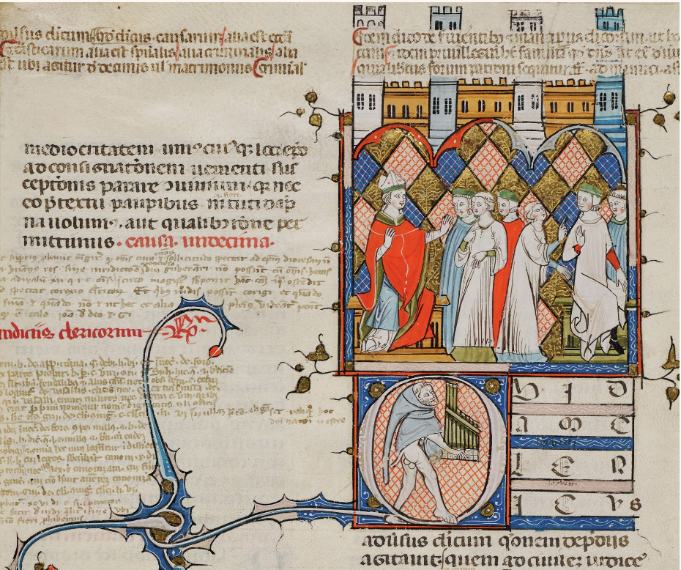
Fig. 1
Letter Q: Court Scene and Initial Q with Grotesque Figure with Organ from a Decretum Gratiani
Southern France, Toulouse (?)
c.1320
The Princeton Art Museum Y1040
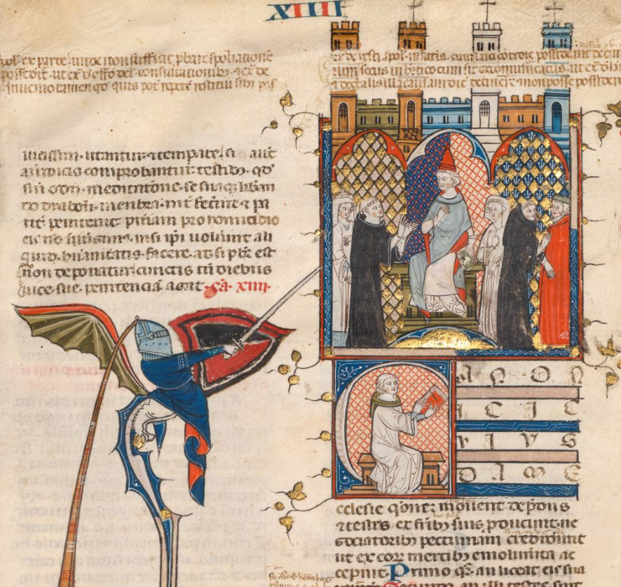
Fig. 2
Leaf Excised from a "Decretum" by Gratian: Initial C
Southern France, Toulouse (?)
c.1320
The Cleveland Museum of Art 1926.245

